EXP 3

AIM : To write an assembly languge program to implement 8 bit multiplication using 8085 processor.

ALGORITHM:

1. We are taking adding the number 43 seven(7) times in this example.
2. **As the multiplication of two 8 bit numbers can be maximum of 16 bits**so we need register pair to store the result.

**PROGRAM:**

**LDA 8500**

**MOV B,A**

**LDA 8501**

**MOV C,A**

**CPI 00**

**JZ LOOP**

**XRA A**

**LOOP1: ADD B**

**DCR C**

**JZ LOOP**

**JMP LOOP1**

**LOOP: STA 8502**

**RST 1**

**INPUT:**

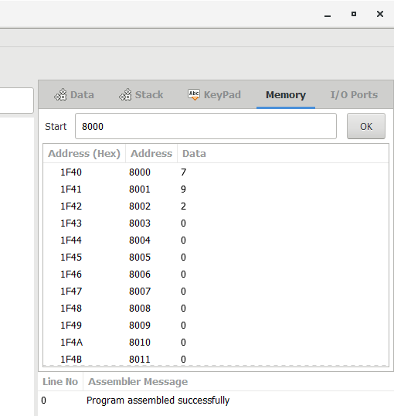

**OUTPUT:**

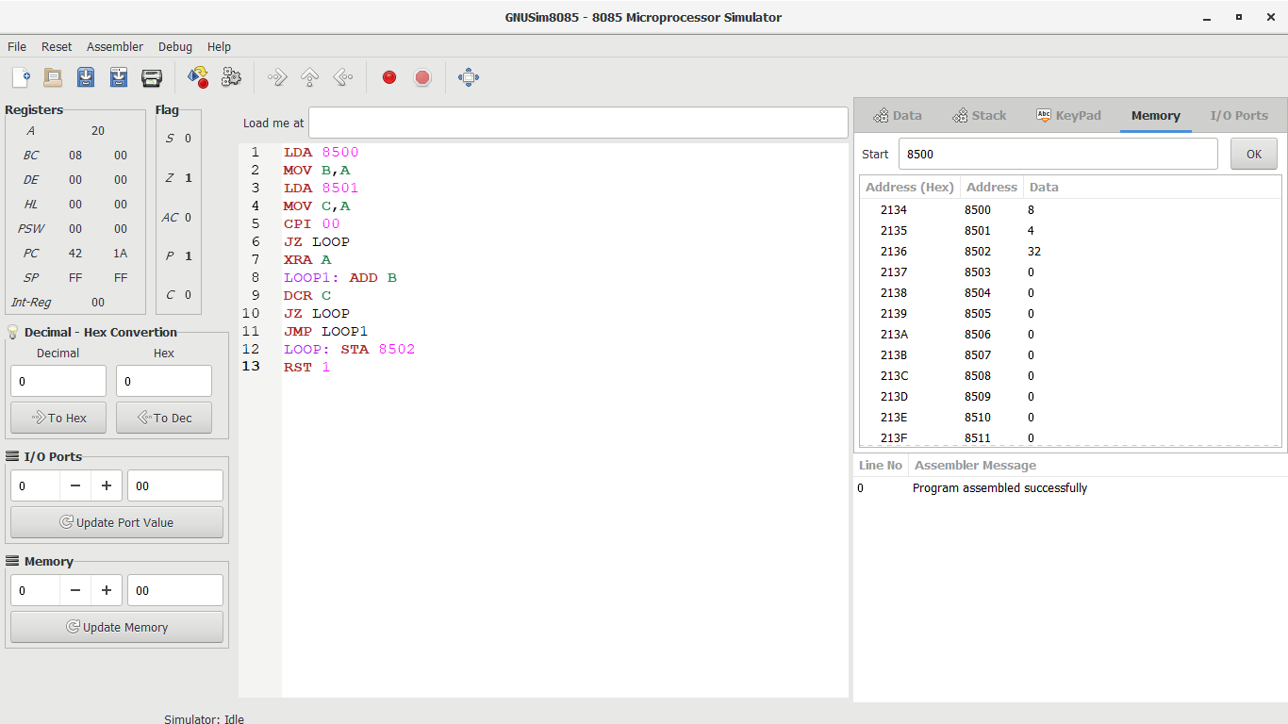

**RESULT:**

**Thus the program was executed successfully using 8085 processor simulator**